Name: Nafinur Leo

Id: 20-42195-1

Course: Computer Organization And Architecture

Section: C

Home Task

Date: 01-02-2022

Task: 1

A = B-A-1

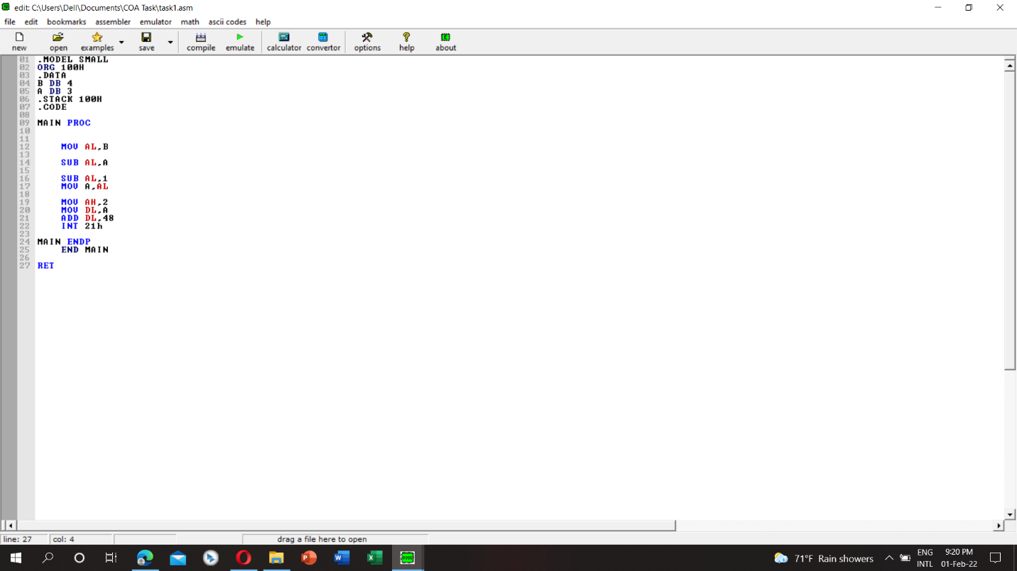

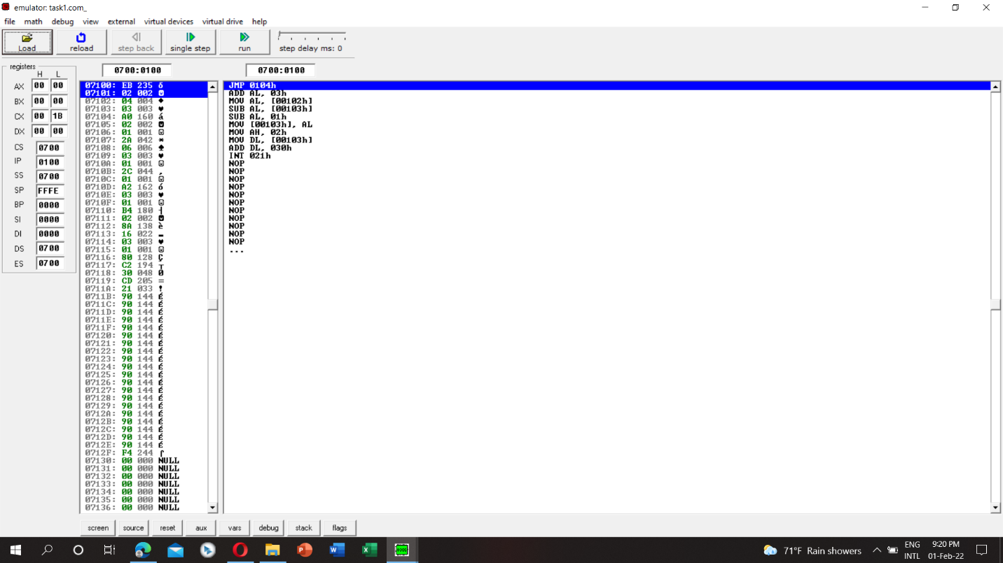

Task:2

B = 3\*B+7

